Access DocuSign
Access DocuSign through the OneCampus Portal
https://one.purdue.edu

Login using your userID and password.
Select DocuSign | 
Select NEW  Select Use a Template |   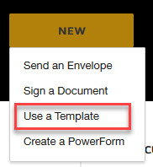
Select Shared Folders click on triangle to expand list | 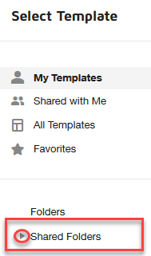
Select the Contract Extension or Non Renewal folder | 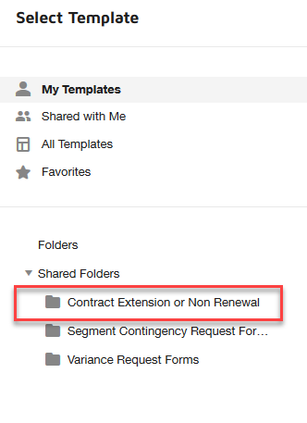
Select the Template  Click ADD SELECTED | 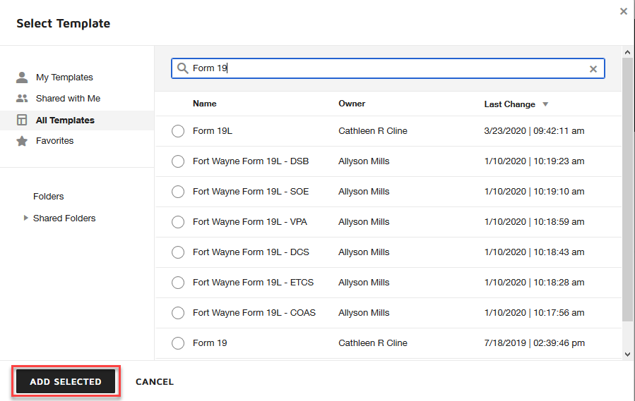
Enter the Recipients of the form as requested | 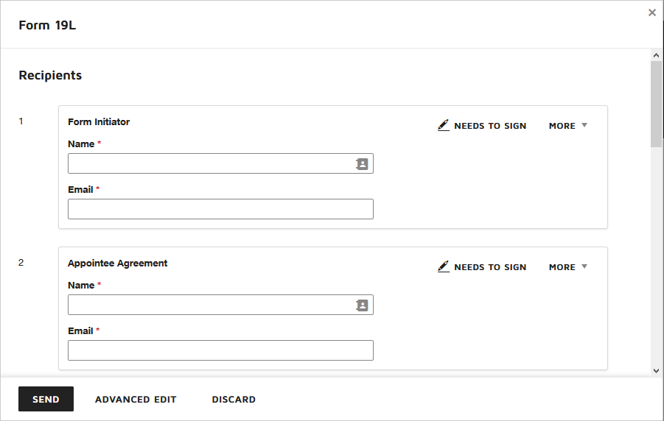
Adding/Removing Signers
REMOVE SIGNER
If Specific Signer is not needed  Hover over the signature block  Remove by clicking X | 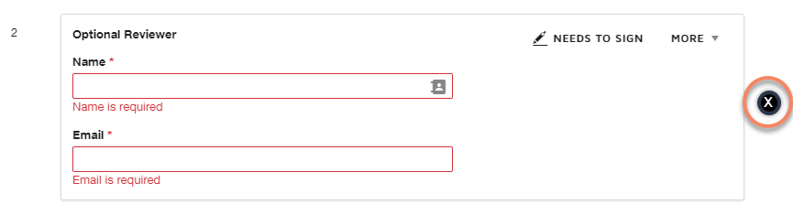
ADD ADDITIONAL SIGNER
If you need to add an additional signer  Click Advanced Edit | 
Scroll to the last signer towards the bottom  Click Add Recipient  Enter signers information  NOTE: This will put the newly added recipient in the last position | 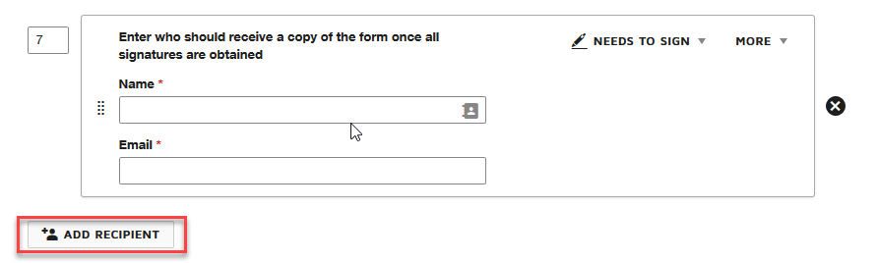
The placement of the signer can be changed by clicking on the rectangle box made of dots  or  by typing in the number of the where the signer will fall into the order | 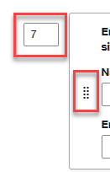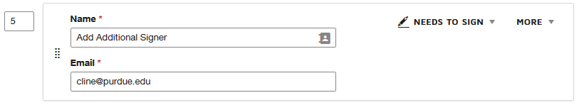
Click Next  Located bottom right of your screen | 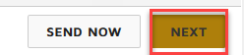
Adding signing line for additional signer  Click drop-down top right  Select Role Name of additional signer (example shows my role name as Added Additional Signer) | 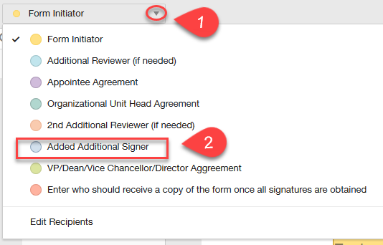
Add Name of Added Additional Signer to the bottom of the form by clicking on Name  Click on Name and drag onto form at the bottom | 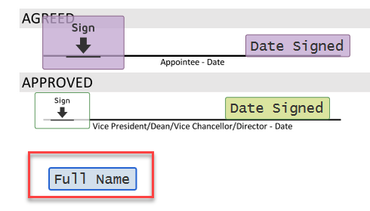  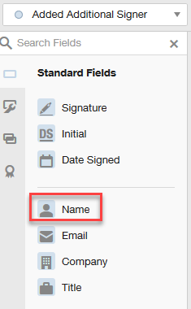
Repeat above step for Signature  Select Signature and place next to name | 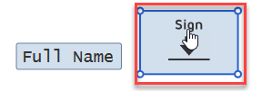  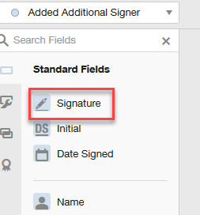
Ready to Send form  Click Send | 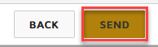
CUSTOM EMAIL MESSAGE TO SIGNERS
If you want a custom message to go to the individual who are signing the form:  Click the Check Box next to custom email  Enter Message  Click Send | 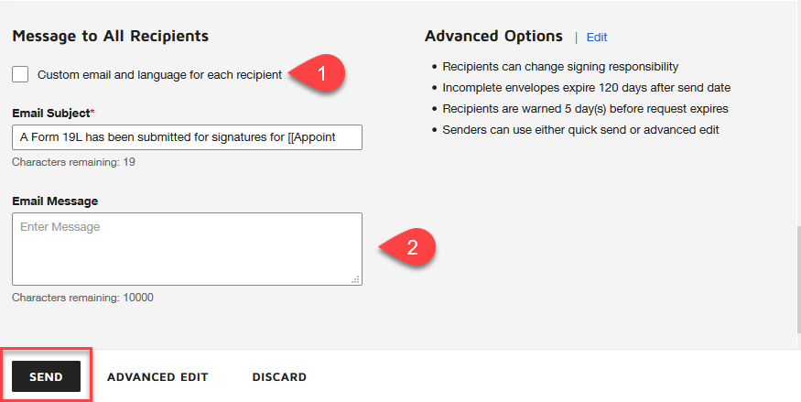
STATUS OF FORM
View Status of form  Click on Home | 
Select Waiting for Others | 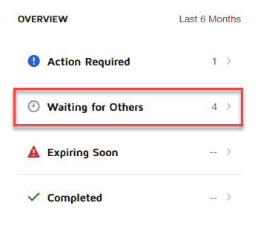
Select Form to see who has signed and who needs to sign | 